Genesys - Copilot Studio Agent Integration

It's a process to place a call back from copilot studio agent to Genesys from copilot studio agent as Microsoft documents suggest no authentication for integration. This process works for all the Authentication types. If a No Authentication setup is followed refer [Hand off to Genesys - Microsoft Copilot Studio | Microsoft Learn](https://learn.microsoft.com/en-us/microsoft-copilot-studio/customer-copilot-genesys-handoff) for setup.

## Prerequisites

These are few things required before setup:

* Copilot studio agent
* Genesys Queue
* Call back APIs provided by genesys.

## Copilot Studio agent setup

Copilot Studio agent allows us to make the REST API calls using two different methods

* Power Apps Custom Connector
* HTTP Trigger in the Topic flow

**Custom Connector:**

This needs to be created in Power Apps. This setup requires some setup

* Service account
* When added in flow, the following should be set up using the service account connection and change end user authentication to **Agent author authentication. This** eliminates the issue with connect or retry connection prompt.

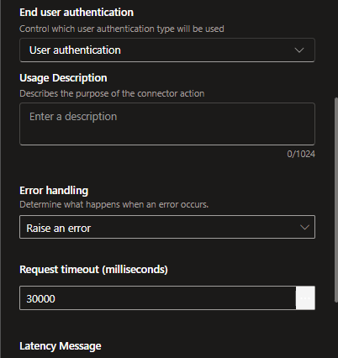

For more information refer [Use connectors in Copilot Studio - Microsoft Copilot Studio | Microsoft Learn](https://learn.microsoft.com/en-us/microsoft-copilot-studio/advanced-connectors)

**HTTP trigger:**

This is available in the flow

* In the flow go to advanced and select Send HTTP request
* 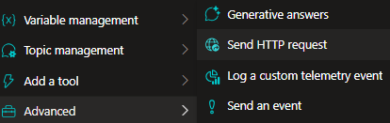
* For more information refer [Make HTTP requests - Microsoft Copilot Studio | Microsoft Learn](https://learn.microsoft.com/en-us/microsoft-copilot-studio/authoring-http-node)

## Architecture

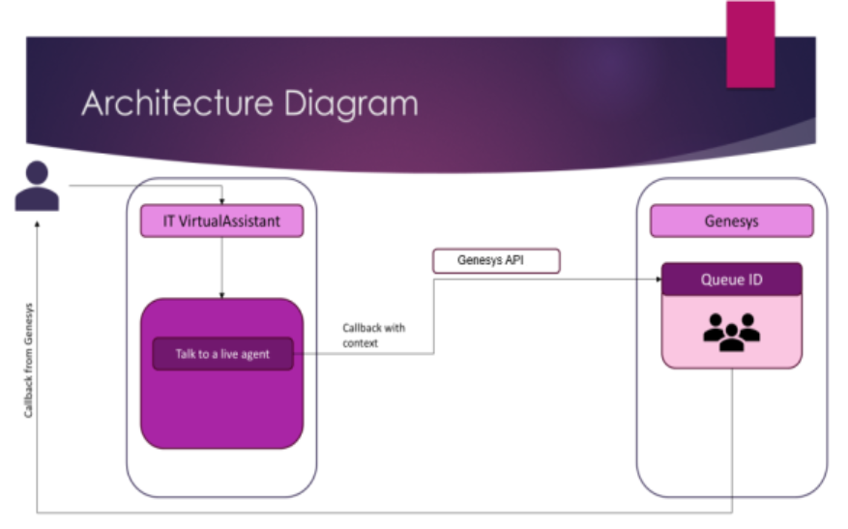

**Process Flow**

When a user requests a callback, we post the request to Genesys callbacks API. We first get an Auth token from Genesys which will later be used to post a call back request API. The request is packed with the basic details of the end user along with the issue description or the context for the live agent to process it. Auth token fetched earlier to this will also be sent for authenticating the request. Once a callback request is placed at the Genesys side, one of the live agents who is on the queue will get it assigned, and the user will get a callback.  
  
Two calls are made here:

* For Auth token (Token valid for 60 mins)
* Place a callback with the auth token

## API Details:

These are used to place a instant call back to the Genesys team. Through this endpoint we send the chat summary, name, mail and contact number.

This happens in 2 stages first we get the secret for the authorization. Using the following Oauth

|  |  |
| --- | --- |
| **Attribute** | **Value** |
| API Path | <https://login.aps1.pure.cloud/oauth/token> |
| HTTP Method | POST |
| Type | Form URL Encoded |

**Request parameters**

|  |  |
| --- | --- |
| **Attribute** | **Value** |
| client_id | Cliend id of app |
| client_secret | Client secret |
| grant_type | Type of the grant |

* This generated token can be valid for only an hour
* This token is used to place the callback to the Genesys

Next, with the token received from the previous call another call needs to be initiated. The call back uses this token for Auth and shares the information through payload.

To place the requirements are:

* Call back contact number with country code (quired the user)
* Auth token generated from the previous call (Placed API call based on the info provided by Genesys)
* Script id - (Provided by Genesys team)
* Queue Id - (Provided by Genesys team)
* CallbackUserName - (Taken from the Authenticate credentials)
* CallerId - (Provided by Genesys team)
* CallerIdName - (Provided by Genesys team)
* Data - (This can be designed as per our requirement)
* CallbackScheduledTime - (This is optional through which the user can set up the time for the callback)

|  |  |
| --- | --- |
| **Attribute** | **Value** |
| API Path | <https://api.aps1.pure.cloud/api/v2/conversations/callbacks> |
| HTTP Method | Post |
| Authorization | Key_from_the_last_call |

**Request parameters**

|  |  |
| --- | --- |
| **Attribute** | **Value** |
| scriptId | Genesys Script ID |
| queueId | Queue ID |
| callbackUserName | User Name |
| callbackNumbers | [“Contact Number with country code”] |
| callerId | Genesys caller Id |
| callerIdName | Genesys Caller Id name |
| data | Email, Conversation Summary, Conversation Id |

DATA parameter contraints:

* While data is being sent from this, the copilot studio has a restriction of 100 characters for each parameter.
* So even if the call is made from the Power Automate flow, this issue persists.
* The following Error may be found in captured variable

Status Code:400

{

"code":"bad.request",

"contextId":"",

"details":[],

"errors":[],

"message":"Additional info value length must be no larger than 100",

"status":400

}